Audio And Video

# Program 1:

<!DOCTYPE html>

<html lang="en">

<head>

    <meta charset="UTF-8">

    <meta name="viewport" content="width=device-width, initial-scale=1.0">

    <title>Audio Example</title>

    <style>

        body {

            font-family: Arial, sans-serif;

            padding: 20px;

        }

    </style>

</head>

<body>

    <h1>Audio Example</h1>

    <audio controls>

        <source src="Audio.mp3" type="audio/mpeg">

        Your browser does not support the audio element.

    </audio>

</body>

</html>

# OutPut :

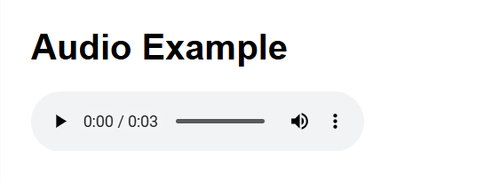

# Program 2:

<!DOCTYPE html>

<html lang="en">

<head>

    <meta charset="UTF-8">

    <meta name="viewport" content="width=device-width, initial-scale=1.0">

    <title>Video Example</title>

    <style>

        body {

            font-family: Arial, sans-serif;

            padding: 20px;

        }

    </style>

</head>

<body>

    <h1>Video Example</h1>

    <video controls width="600">

        <source src="Video.mp4" type="video/mp4">

        Your browser does not support the video element.

    </video>

</body>

</html>

# OutPut :

